**Changes to be made:**

Dose4 page:

Start of last dot point has first letter cut off:

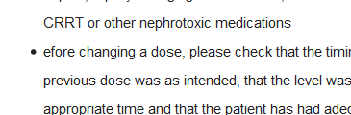

Banner for TEAMS on home page:



The Northern Territory Government Flower should blend with the image. This is colour #0086B9



If you hit the back button on the browser then the last page will not load, I’m not sure whether you put a script in there to disable it?

The page you have made is loading a little slowly in the browser compared to the original file

The ascending cholangitis page is not the same as the pelvic inflammatory page for the dot points at the bottom. (one has the dot points in blue and the other in black). I think I would prefer the black option (pelvic inflammatory disease) if choosing between the two.

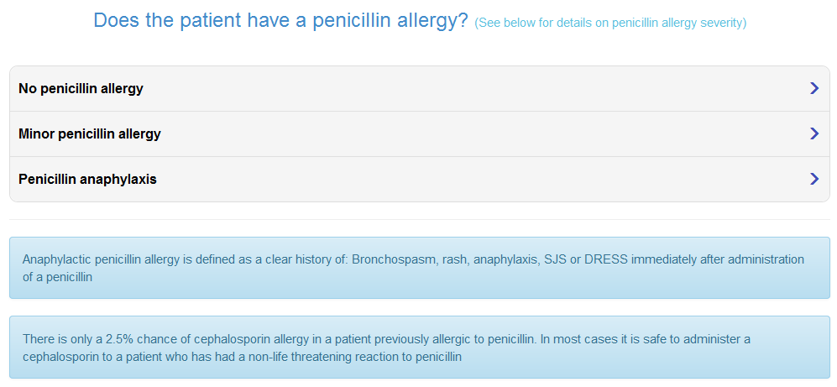

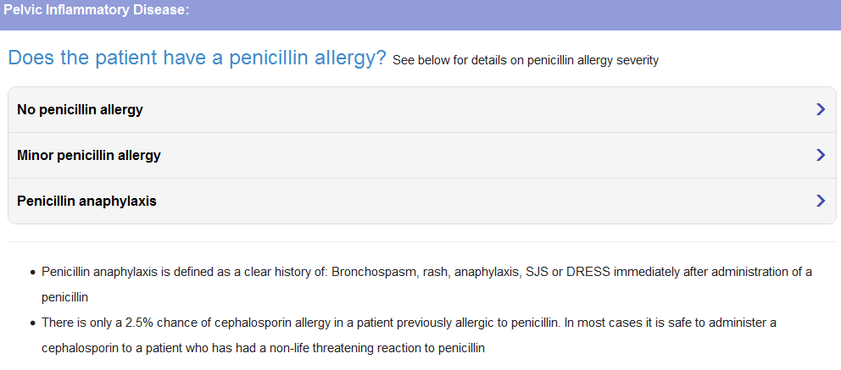

The lists are not highlighting and are only functioning if you press them in the centre, I am not sure if this is because maybe the class=”search-control listview” has been added? I think the data-filter=”true” was doing the same thing.



I am not sure why either, but the autodividers aren’t working in the new file